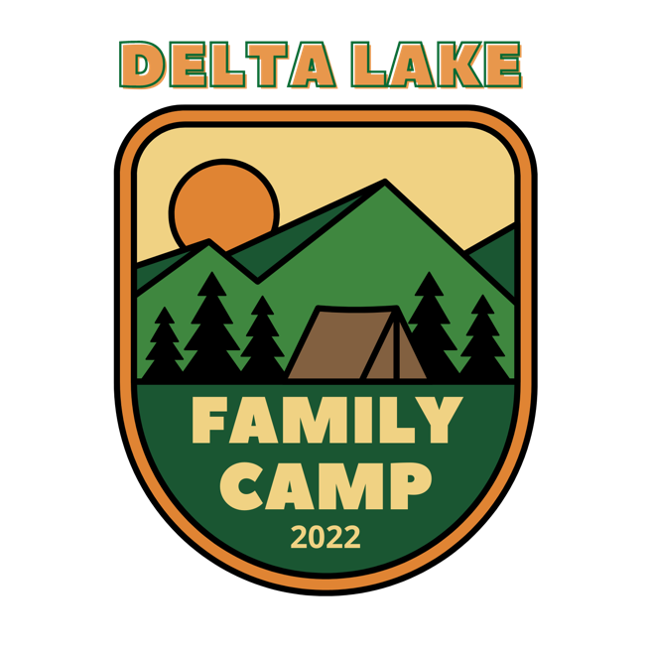
MAIN TABERNACLE SCHEDULE

FRIDAY, July 1st

7:00pm Opening Service w/ Dan Richter

SATURDAY, July 2nd

10:00am IW Hour w/ Larry & Karen Wolters
11:00am Morning Bible Hour w/ Bryce Baldwin
7:00pm Evening Worship Service w/ Dan Richter

SUNDAY, July 3rd

10:00am Family Worship Service w/ Dan Richter
*Childcare available for birth up to 5th grade
7:00pm Concert w/ Mark Cable

MONDAY, July 4th

10:00am IW Hour w/ IW Parent Roundtable Discussion
11:00am Morning Bible Hour w/ Wayne Eppenheimer
7:00pm Evening Worship Service w/ Keith Wilson

TUESDAY, July 5th

10:00am IW Hour w/ Wayne & Susan Spronk
11:00am Morning Bible Hour w/ Wayne Eppenheimer
7:00pm Evening Worship Service w/ Keith Wilson

WEDNESDAY, July 6th

10:00am IW Hour w/ Wayne & Susan Spronk
11:00am Morning Bible Hour w/ Wayne Eppenheimer
7:00pm Evening Worship Service w/ Keith Wilson

THURSDAY, July 7th

10:00am IW Hour w/ Julie Hillis, Haven Camps Director
11:00am Morning Bible Hour w/ Frank Chan, Nyack College
7:00pm Evening Worship Service w/ Keith Wilson

FRIDAY, July 8th

10:00am IW Hour w/ Greg Wolters, Head of NED Missions Committee
11:00am Morning Bible Hour w/ Melanie Thornton
7:00pm Closing Service w/ Keith Wilson

