ACTIVITIES SCHEDULE

SATURDAY, July 2nd
1:30pm Soccer Game (Ballfield)
2:30pm Memorial Celebration – Sparky Steiner (Delta Dining Room)
3:00pm Sand Volleyball (Sand Volleyball Court)

SUNDAY, July 3rd
2:00pm Softball Game (Ball Field)
3:00pm Alliance Women RENEW (Delta A)
7:00pm Concert – Mark Cable (Main Tab)
8:30pm Strawberry Shortcake Social (Delta Dining Room)

MONDAY, July 4th
6:00am *Paddleboard Trip (Waterfront)
7:30am Flag Raising (Delta Commons)
1:30pm July 4th Bike Parade (Meet by the Delta Café)
2:00pm Family Activities on the Main Tab Field
2:00pm Book Folding Art (Main Tab)

TUESDAY, July 5th
6:30am *Sunrise Fishing Trip
6:30am Morning Exercise Class (Delta A)
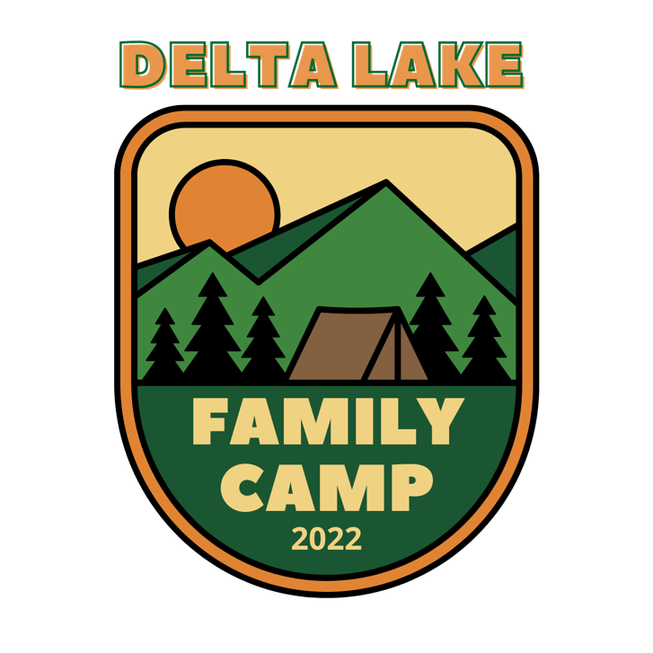
12:30pm *Slocum Golf Tournament (Meet @ Sleepy Hollow GC)
2:00pm Ultimate Frisbee (Ball Field)

WEDNESDAY, July 6th
6:00am *Paddleboard Trip (Waterfront)
6:30am Morning Exercise Class (Delta A)
1:00pm *Stumbo Run (Meet by Delta Café)
3:00pm *Horseshoe Tournament (Horseshoe Pits)
4:00pm Bocce Ball (Main Tab Field)

THURSDAY, July 8th
6:30am Morning Exercise Class (Delta A)
2:00pm Soccer Game (Ball Field)
2:00pm Nyack College Informational Gathering (Delta Dining Room)
3:30pm Family Kickball (Ball Field)

FRIDAY, July 9th
6:30am *Paddleboard Trip (Waterfront)
2:00pm Archery Tag (Gym)
3:00pm Softball (Ball Field)

Any activities that have an * by them require a sign-up at the Registration Building

